­­­­[TC] – Medic Guide

August 2012 Edition

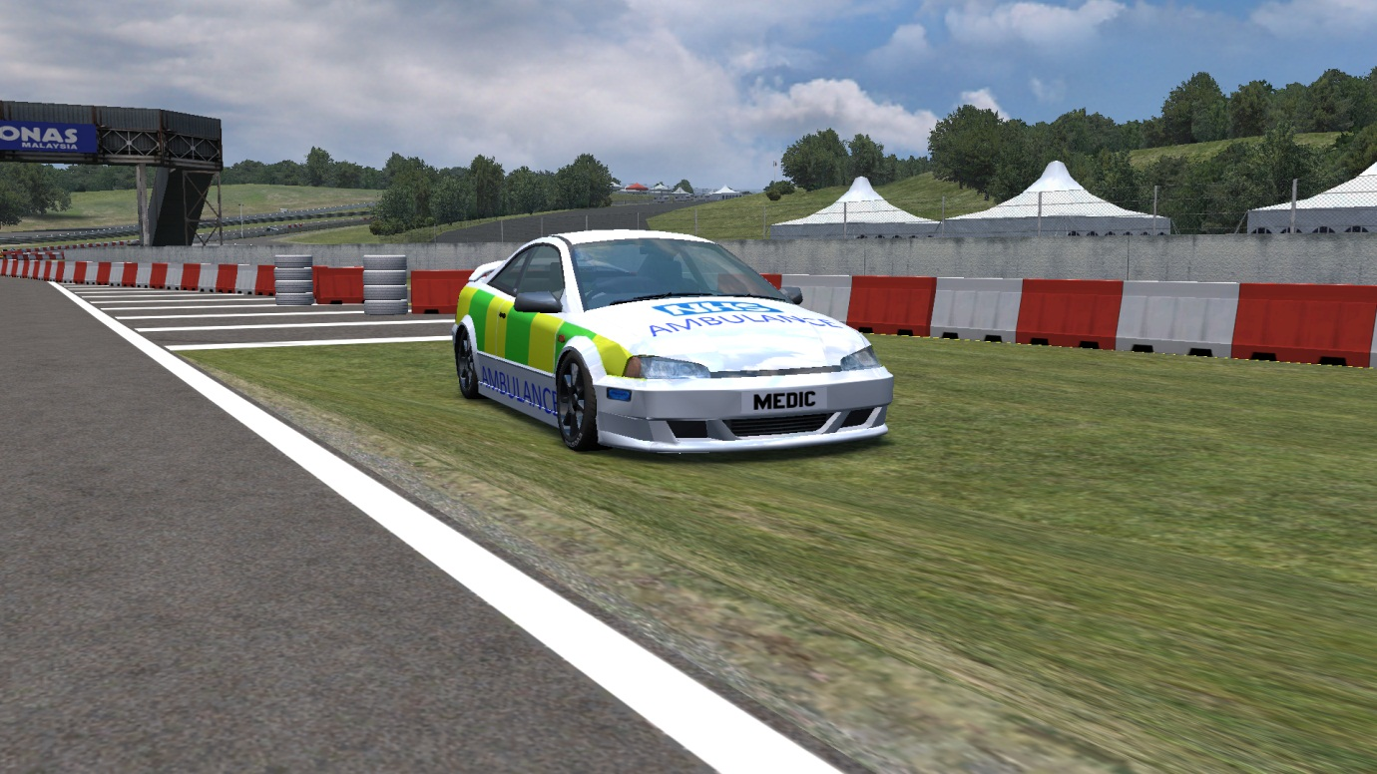­­

By Luke

Contents

1 – Introduction ………………………………………………………………… 3

2 – Hotkeys …………………………………………………………………. 4 & 5

3 – Responding to a tow ……………………………………………… 6 & 7

4 – On Scene ……………………………………………………………………… 8

4 – Towing Techniques ………………………………………………………. 9

5 – Miscellaneous ……………………………………………………………. 10

6 – Conclusion …………………………………………………………………. 11

Introduction

This guide is designed to help Medics perfect and enhance their towing technique and standard, and give them the necessary skills to tow a car successfully. This guide also shows you how to respond to an incident quickly and safely, using only audible sirens and strobes, and teaches you how to control the scene of an accident, preventing more accidents and keeping the streets of TC clear.

Please take your time to study this guide, and enjoy using your new skills on the [TC] servers.

Thanks, Luke.

­

Hotkeys

Hotkeys:

As a Medic on [TC] servers, you don’t need an entourage of hotkeys, but you do need a select few to help you in your tow situations. Listed below, are a few hotkeys that I would recommend using as a Medic (that I use myself.)

* Type !calltow for a Rapid Response Medic

Use this bind to help remind people that you are there, as a lot of drivers normally crash/flip, lose patience and just pit straight away. This reminds them that they don’t always have to lose their trip and get annoyed. Try to glam this up a bit – change the colour, add some interesting symbols – this will make it more noticeable.

* A Rapid Response Medic will be there within 1 minute

Use this bind to reassure the driver that you’re coming – you don’t want to ignore them as they might not be aware you’re responding to them. Try to include a time-scale – in most cases you will be there within 1 minute, and it reassures the driver you’ll be there quickly, and not take too long.

* Medic Responding – Please Move

Use this bind if you can’t get someone to move over. Although drivers are not obligated to move out of the way, most of them do when they’re aware of your presence, so this useful little bind will definitely make them aware you’re right behind them!

* Thanks for letting me through!

Use this to thank courteous drivers for moving out of your way – this makes them more likely to move next time because of your politeness.

* Warning – Accident at: <type !direction>

Use this bind when you arrive at an accident. This warns other drivers that an incident has occurred – this is vital as you do not have hazard/caution signs.

Responding to a Tow

As a Medic, your aim is to get to the driver-in-distress as quickly as possible, and as safely as possible – no one likes to be hit or wrong-sided. So, when responding to an Emergency call, follow these instructions carefully:

1. Make sure you activate your strobes and audible sirens – otherwise, drivers won’t know you’re responding to an emergency, so it will make you less visible, and it will be less likely that drivers move out of the way.
2. If you approach traffic, make sure you take a strong, offensive position in the road, so the driver in front can clearly see you in their mirrors. This is depicted clearly in the diagram below:

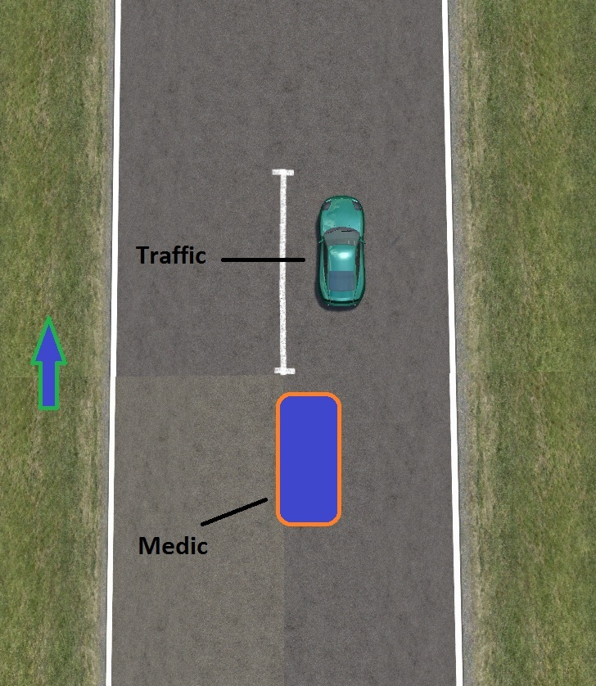

As you can see in the diagram, the Medic car is towards the middle of the road, so it is ready to overtake the traffic. This position also makes you more visible to the car in front and better shows your intentions of overtaking. It’s also quite an aggressive driving position, which makes it more likely for the traffic to give in and move out of the way for you.

1. Never overtake on corners, wait for the traffic to continue around the corner. If the traffic in front does pull over on the corner, make sure you stay as close to the right side of the road as possible.
2. There is no law to say that you cannot speed when responding to an emergency. But, if you are caught by cops, you are likely to be chased and fined. So if you come across a Cop whilst responding, make sure you slow to the speed limit if you don’t want a fine.
3. When approaching a junction, make sure your audible siren is on. Using horn 4 is a good choice when approaching a junction, because is catches the drivers’ attention more. When you approach the junction, slow down so you can see the traffic approaching from both sides. Edge forward slightly, to show that you need to pull out. Do not pull out and expect drivers to swerve/move for you, as this will likely result in a crash and a very annoyed driver. Wait at the junction, and if a driver does let you out, proceed (make sure you thank them!)
4. At a roundabout, slow down so you can see a car coming. Edge forward slightly, to show that you need to pull out. Do not pull out and expect drivers to swerve/move for you, as this will likely result in a crash and a very annoyed driver. If they choose to let you through, go ahead, but if not, wait for them to pass.
5. If a driver does not move for you, assume that they haven’t seen you, use the bind “medic responding, please move” to get their attention. If they still don’t give way, assume that they don’t want to. If this is the case, follow more closely, increase speed and switch to horn 1, and give them a good blast of it, then pass them – with caution – and take care to monitor the map and road for oncoming traffic.
6. Always remember to thank drivers if they move out of the way – this makes them more likely to move next time because of your politeness.

On-Scene

This list of instructions shows you what to do whilst at the scene of an accident. Follow these step-by-step instructions that show you how to operate a risk-free tow operation:

1. Use the bind “Warning – accident at <type !direction>” as soon as you approach an accident.
2. Pull over to the side of the road, and turn of your audible siren. When it is off, switch it to horn 4 (I will explain soon.) Make sure strobes are on.
3. After checking for traffic, tow the driver. If they are on the road, try to push them towards the side of the road, or onto the grass, to minimize accidents.
4. If it is impossible to tow them towards the side of the road (e.g. the autobahn), this is where horn 4 comes in. If traffic is approaching, blast horn 4 whilst they approach to give them further warning (but good luck on the autobahn, because even cautions are close to useless there!)
5. If traffic does approach and doesn’t appear to notice you or slow down, pull to the side so you minimize the chance of a collision.
6. When you have finished towing the driver, pull over to the side of the road immediately. If you’re feeling cheeky enough, you might want to say something along the lines of “donations are welcome” – just make sure you don’t say “Give me money”.

Here are some extra little tips:

* If a chase is coming, pull over as normal, and if possible, move the crashed car out of the way.
* If a tow comes along, (without sounding harsh) tell them to go away or put a hazard/caution sign up. The last thing you want is a crowded scene, with cars in the middle of the road and tows arguing about who’ll tow.

Towing Techniques

There are various ways to tow a vehicle – reverse into it, hit it with your front bumper or you could do a full speed kamikaze handbrake drift spin into it (not recommended.) My favourite, tried and tested method would be reversing into the crashed driver (when flipped.) If this fails to work for some reason, give them a nice smack at high-speed (please be aware of other road-users), as that will at least give them a small chance of going flying and landing on their wheels.

When towing a car that has run out of fuel/clutch is burnt out, take these tips into consideration:

* Stay close the right side of the road.
* Try to stay under 40 mph, as above that it’s easy to lose control with a damaged car.
* Don’t nudge the damaged car too hard, as this may send them into a spin or wall.
* If traffic is approaching at high-speed, blast horn 4 to help warn them.

Miscellaneous:

Skins:

Having a Medic skin is vital, so you can be easily seen and identified. Check of the [TC] Skin area for my medic skins. I have only made skins for certain cars, so please email me at [wishartluke@yahoo.co.uk](mailto:wishartluke@yahoo.co.uk) if you would like a skin made for a specific car.

Cars:

Having the right tow car is vital for towing success. Stay away from Forward Wheel Drive cars, such as the FXO and XRT (you can still use them, but good luck in the sand pits.) The RB4 is a perfect Tow car, due to its weight, size and ability the glide over the sand pits.

Towing Aids:

[TC] Lights Strobe/Siren program is a must-have when being a medic. You can download it here ----> <http://forum.citydriving.co.uk/showthread.php?tid=200> Also, downloading a siren horn for horns 4 & 5 is essential too. You can find these easily on Google/YouTube and on the TC website.

Also, having a locator is a good choice as it allows you to easily locate the crashed car on the map. These are not cheap, so if you’re tight on money, just spec the driver, and see where they are on the map.

Conclusion

Thank you very much for reading the Medic guide, and I hope you enjoyed reading it and found it to be a useful source of information. If you have any questions, email me at [**wishartluke@yahoo.co.uk**](mailto:wishartluke@yahoo.co.uk)**,** and if you have any suggestions of anything to add to the guide, please email me too.

Thanks,

Luke (Lukey747)